**DIGITAL MARKETING BOT DOCUMENTATION**

* PLANNING

1. A marketing bot which will be able to automate the following social media platforms:

* Facebook
* Instagram
* Linkedin
* Twitter

1. It can send promotional messages to particular group of people, post content, send requests and accept requests from the logged in account.
2. Inputs should be provided through a Ms-excel file. A proper format is decided in a particular order to provide all required inputs which must be followed for accurate execution.
3. Then creating addons as per the requirement.

* CREATING ADDONS/COMMANDS

We have to work in visual studio for creating an addon for each platform i.e, facebook, instagram, linkedin and twitter. Required commands should be created separately for each addon. The commands used in this project are mentioned below:

FACEBOOK COMMANDS:

***Note: Account’s unique id should be mentioned in the following commands. It can be noted from the url of any profile after facebook.com/***

* **Facebook.login** – This command is used to login to a particular facebook account.

**Inputs required** – email [text] and pword [text]

* **Facebook.sentfriendrequest** – This command is used to send friend request to a person whose unique id is provided.

**Input required** – id [text]

* **Facebook.sendmessage** – This command is used to send the content provided in message to the person whose unique id is provided.

**Inputs required** – id [text] and message [text]

* **Facebook.createpost** – This command is used to post any content on facebook.

**Input required** – post [text]

* **Facebook.acceptfriendrequest** - This command is used to accept someone’s friend request on facebook. It can accept requests from 1 to 5 accounts depending on the input provided.

Input required – number [integer]

**INSTAGRAM COMMANDS:**

***Note: Account’s unique username should be mentioned in the following commands. It can be noted from the url of any profile after instgram.com/***

* **Instagram.login** – The command is used to login to a particular instagram account.

**Inputs required** – username [text] and pword [text]

* **Instagram.follow** – This command is used to send follow request to any person or page on instagram whose unique username is provided in the input.

**Input required** – username [text]

* **Instagram.sendmessage** – This command is used to message the content provided in message to the person whose unique username is mentioned.

**Inputs required** – username [text] and message [text]

* **Instagram.acceptrequests** – This command is used to accept follow requests on instagram. It can accept requests from 1 to 5 accounts depending on the input provided.

**Input required** – number [integer]

**INSTAGRAM APP COMMANDS:**

***Note: Appium must be enabled first on your system to use these command.***

* **Instagramapp.open** – This opens the instagram application in your phone and login to your account.

**Inputs required** – email [text] and pword [text]

* **Instagramapp.makepost** – This post the image from your account whose number is mentioned. For example, if imagenumber is 3, it will post 3rd picture from your gallery.

**Input required** – imagenumber [integer]

**LINKEDIN COMMANDS**

* **Linkedin.login** – This command is used to login to a particular linkedin account.

**Inputs required** – email [text] and pword [text]

* **Linkedin.makeconnection** - This command is used to send connection request to any person or page on linkedin whose unique nameid is provided in the input.

**Input required** – nameid [text]

***Note: Account’s unique nameid should be mentioned in the above command. It can be noted from the url of any profile after linkedin.com/***

* **Linkedin.sendmessage** – This command is used to message the content provided in message to the person whose name is provided in input.

**Inputs required** – name [text] and message [text]

* **Linkedin.post** - This command is used to post any content on linkedin.

**Input required** – post [text]

* **Linkedin.acceptrequests** - This command is used to accept follow requests on linkedin. It can accept requests from 1 to 5 accounts depending on the input provided.

**Input required** – number [integer]

**TWITTER COMMANDS**

* **Twitter.login** – The command is used to login to a particular twitter account.

**Inputs required** – email [text] and pword [text]

* **Twitter.follow** – This command is used to send follow request to any person or page on twitter whose unique username is provided in the input.

**Input required** – username [text]

* **Twitter.sendmessage** – This command is used to message the content provided in message to the person whose name is provided in input.

**Inputs required** – name [text] and message [text]

* **Twitter.post -** This command is used to post any content on twitter.

**Input required** – post [text]

* PROVIDING INPUTS IN EXCEL FILE:

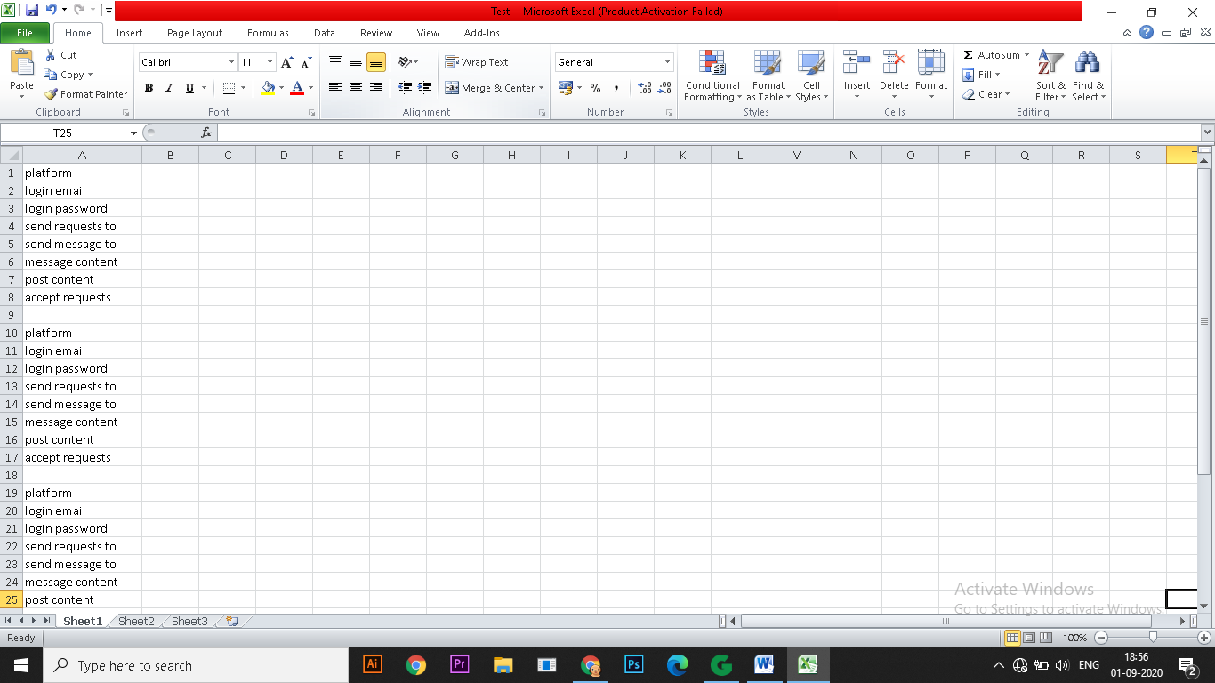

The following instructions must be kept in mind while providing inputs in excel file:

* **Platforms must be entered in alphabetical format**

For example, if you want to automate all platforms then 1st facebook and its all fields should be filled then 2nd instagram and its all fields then 3rd linkedin and lastly 4th twitter. If any three then instagram, linkedin and twitter in this order and so on for any possible case.

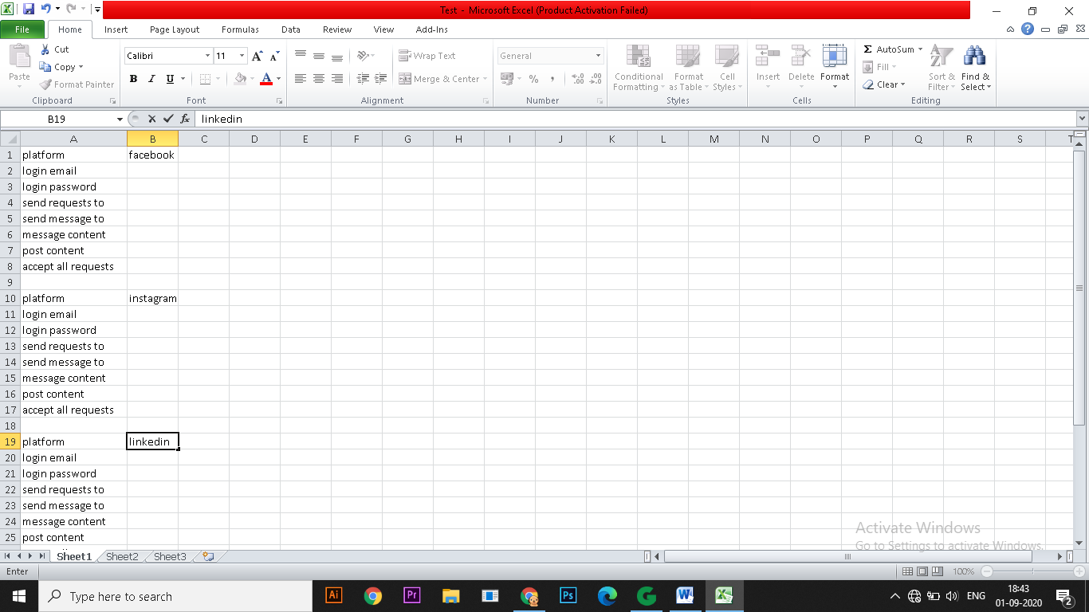

* **All inputs should be provided to the adjacent column to the field i.e, column B**

As you can see in the screenshot , all the field names are given in column A in different rows so their respective entries should be made in the column next to these i.e, in column B without leaving any column in between.

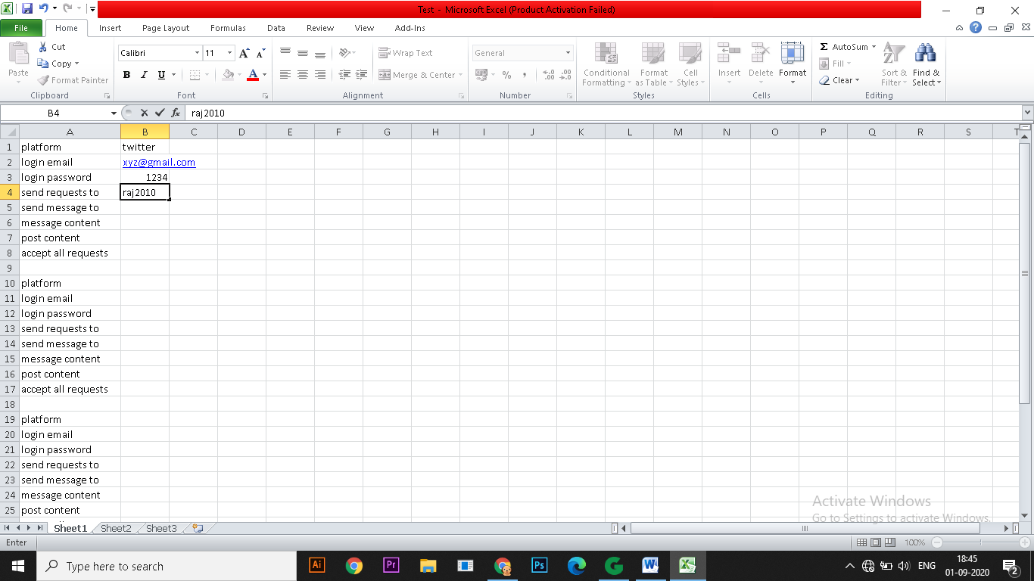

* **For multiple entries:**

For multiple entries in commands like send message and send requests where the same command is used again and again for different subjects, entries should be made one by one from column B to K in front of the respective field without leaving any column blank in between.

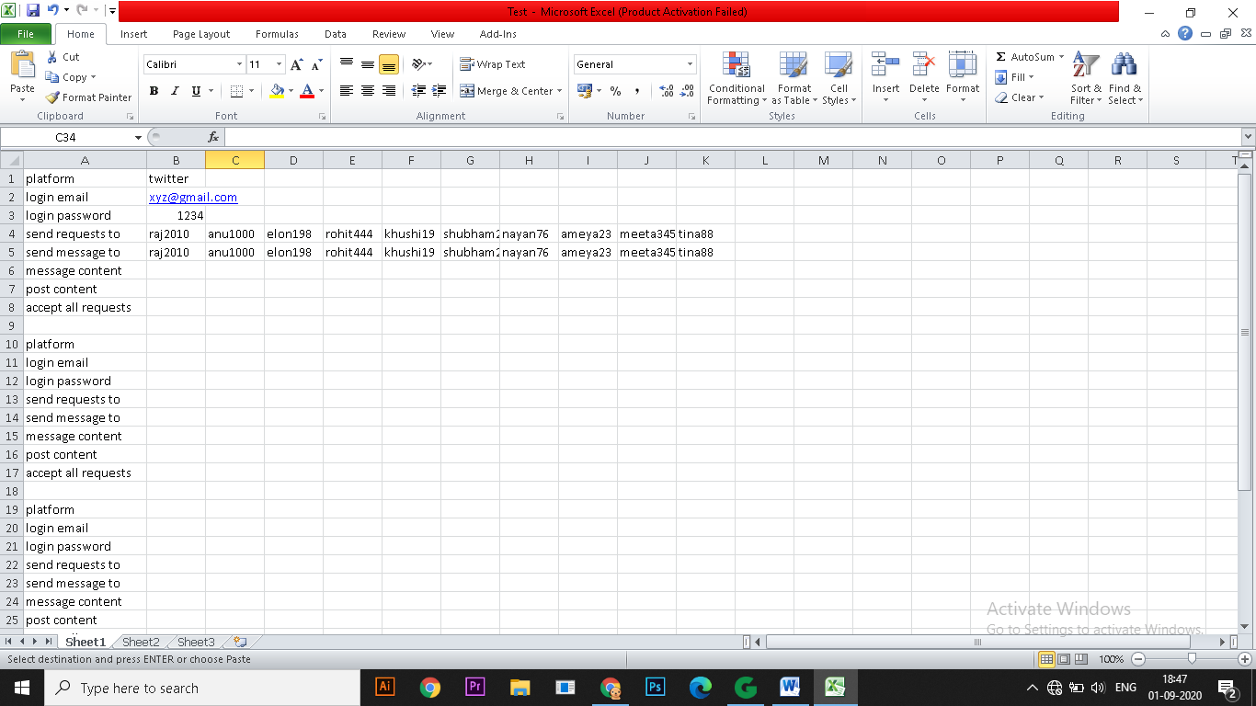

* **Input should be provided in proper format**

Every command’s input type is mentioned in the command’s section of this documentation. So, while providing input in excel file it must be noted that input is in right format. For example, in instagram post field input should be an integer and for instagram send request field input should be text.

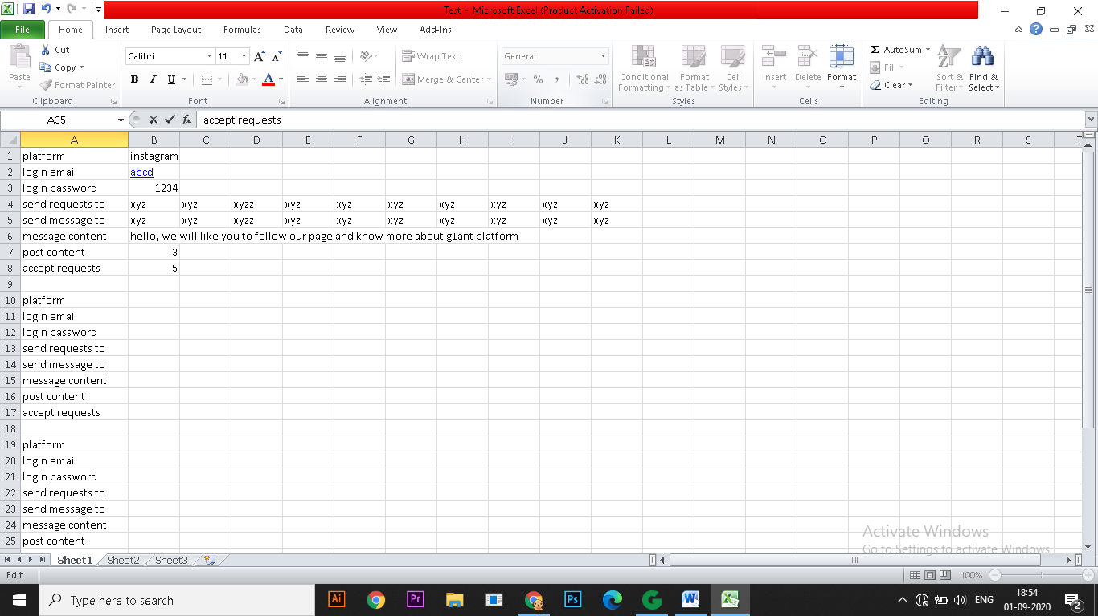

* CODE WRITING :

1. We have used g1ant studio platform to write our project code because of its user-friendliness and effectiveness in automation.
2. The code was written with the help of specific addons like xxx(Enter here the addon names for specific project ) we created in step 2 of our project and basic g1ant studio addons like microsoft and core were used.
3. And at the end, the simple conditional statements in C language were enough for the code to be functional and on point.

Changes which can be performed in code:

* **Name and Location of excel file**

By default, the code opens a file named Test present on Desktop but if your file name is different and it has different path, it can be changed in the first line of code where excel.open command is used.

* **If you do not require any step to be completed or if any field is left empty in the excel file, then that part of the code can be deleted.**

For example, if you do not want to post on instagram and only wants to perform the send message, send request, accept requests action then this code should be deleted.

*instagramapp.open email ♥email1 pword ♥pword1*

*instagramapp.makepost imagenumber ♥post1*

Another example, if you do not require to send friend requests in facebook then this code should be deleted.

*for counter ♥colin from 2 to 11*

*excel.getvalue row 4 colindex ♥colin result ♥req100*

*facebook.sentfriendrequest id ♥req100 search hi*

*end*

* The code is prepared for 10 entries each in send message and send requests commands for all platforms. This means there must be exact 10 entries for these commands. If you want to change this number let’s say to n entries then you must replace 11 to n+1 in every for command. It will be easier to just replace 11 to n+1 using **replace command provided in Edit menu.**

For example, if 5 entries are to be made then replace 11 to 6.

* EXECUTION

The code we wrote in g1ant studio is now executed considering all the possibility by creating sample data in excel file which is basically used for the customer to provide their preferences in specified format. It identifies the case and follows all the steps mentioned in the case. The only problem which may occur in the code is that if it broke at any step, it will require us to click on run button manually to continue it. To avoid this, timeout may be increased.